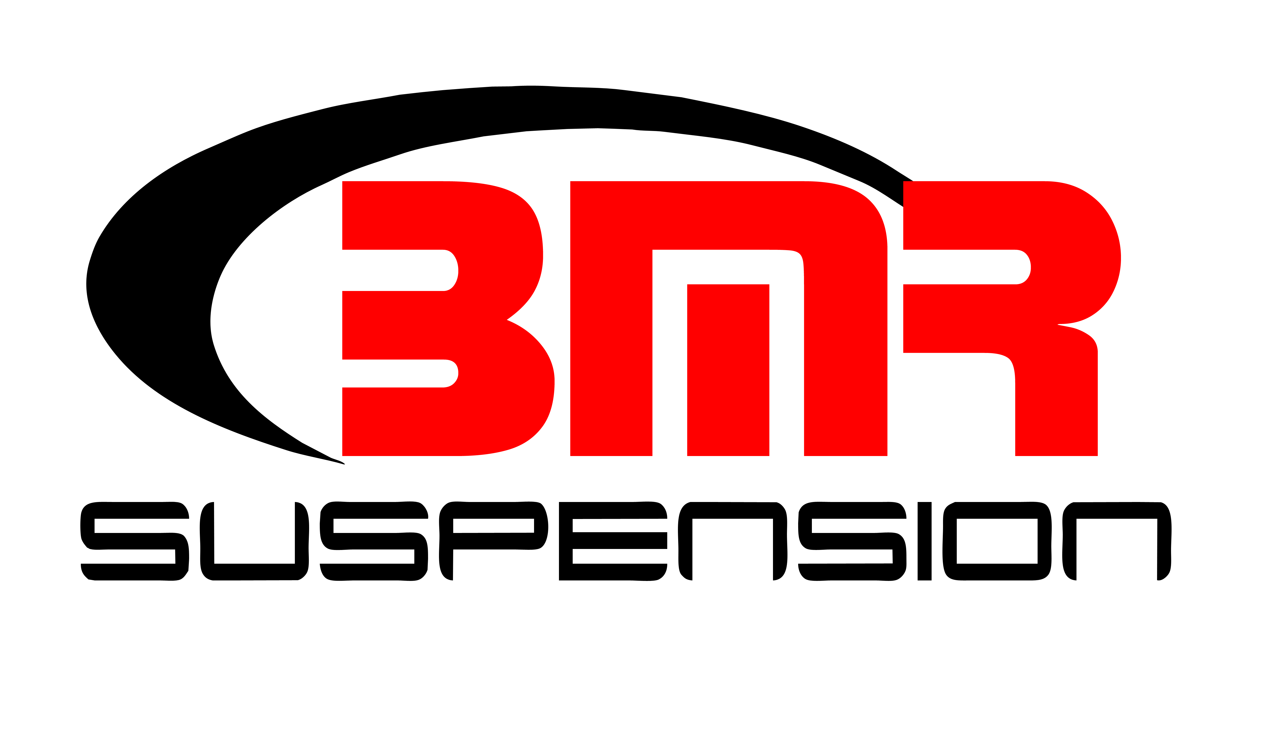

FOR IMMEDIATE RELEASE

BMR Suspension Caster Camber Plates for 2016-2023 Camaro
WAK360 - $279.95
WAK361 - $349.95

Add caster and camber adjustability, and fix alignment issues on your lowered Sixth Gen Camaro with Caster/Camber Plates from BMR Suspension. The factory alignment adjustability can be insufficient when you lower your 2016-2023 Camaro. Manufactured from CNC laser cut 3/16” steel plate, BMR’s Caster/Camber Plates are designed to add caster and camber adjustability to the Sixth Gen Camaro front suspension that isn’t available from the factory. The WAK360 caster camber plate is specifically designed to accommodate factory-style coil spring configurations, whereas the WAK361 is precisely tailored for coilover setups. The BMR Caster/Camber Plates (WAK360/WAK361) give you a total camber range of 2.5 degrees to ensure easy adjustability with the added benefit of quickly tracking varying camber adjustments. BMR also replaces the weak factory strut mount bushing with high-quality, USA-made, Teflon-lined spherical bearings. BMR has designed the WAK360/WAK361 to correct the alignment on a lowered Sixth Gen Camaro and add aggressive alignment settings for both the street and track. Installation time is 1-2 hours. Available in black hammertone or red powdercoat for long lasting good looks. Proudly made in the U.S.A

To preview all of BMR’s high-performance suspension parts, please visit www.bmrsuspension.com, email sales@bmrsuspension.com, or contact them at BMR Suspension, 928 Sligh Ave, Seffner, FL 33584, 813-986-9302, Fax: 813-986-8055.

Editors: Download this press release and high resolution images at: www.bmrsuspension.com/?page=pressrelease

